**Voyage Vista: Illuminating Insights from Uber**

***Insights from Uber***

1.1 Overview:

Uber, a global ride-sharing and transportation company, has generated a wealth of insights from its operations, transforming the way people travel and disrupting traditional transportation models. These insights have not only revolutionized urban mobility but have broader implications for various industries and sectors.

Uber has developed sophisticated algorithms and data-driven systems to analyze demand and supply patterns in real-time. This enables them to match drivers and riders optimally, reducing wait times and improving overall efficiency. The understanding of demand-supply dynamics has implications beyond transportation, as it showcases the power of data and algorithms in matching supply and demand in various contexts.

Uber introduced surge pricing, a concept where fares increase during peak demand periods. This dynamic pricing strategy helps to balance supply and demand, incentivize more drivers to come online, and ensure reliable service availability during high-demand periods. This concept has implications for other industries, such as hospitality, events, and concerts, where pricing can be adjusted based on demand fluctuations.

1.2 Purpose:

Uber's insights provide valuable data and analysis that can inform decision-making and strategic planning. By understanding demand patterns, pricing dynamics, and user preferences, businesses and policymakers can make informed choices about resource allocation, expansion plans, and service enhancements.

Problem Definition & Design thinking

2.1 Empathy Map

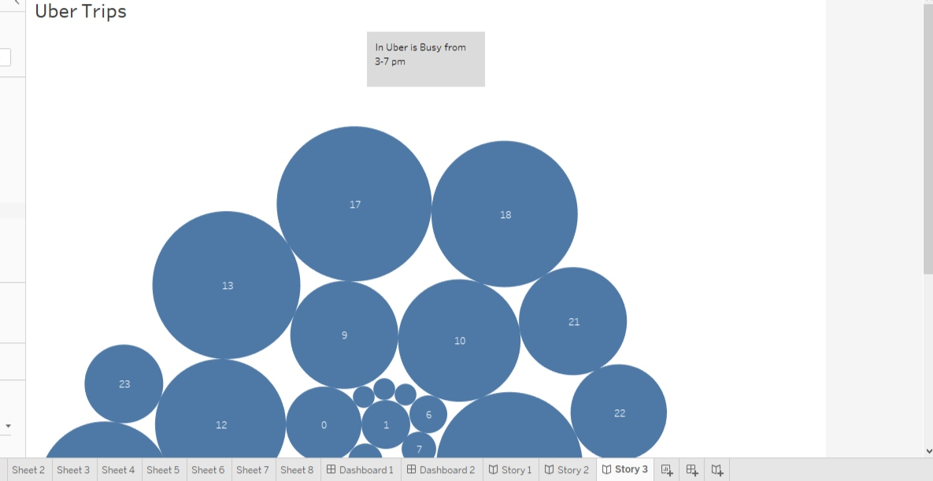

2.2 Ideation & Brainstorming map:

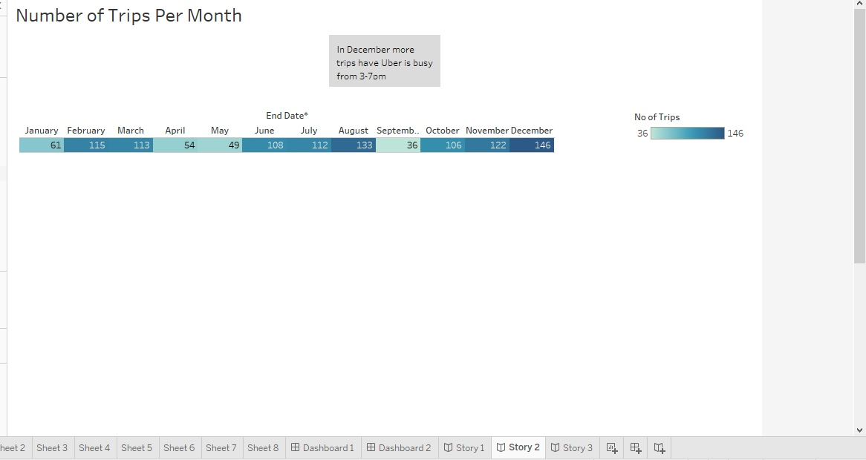

3. Result:

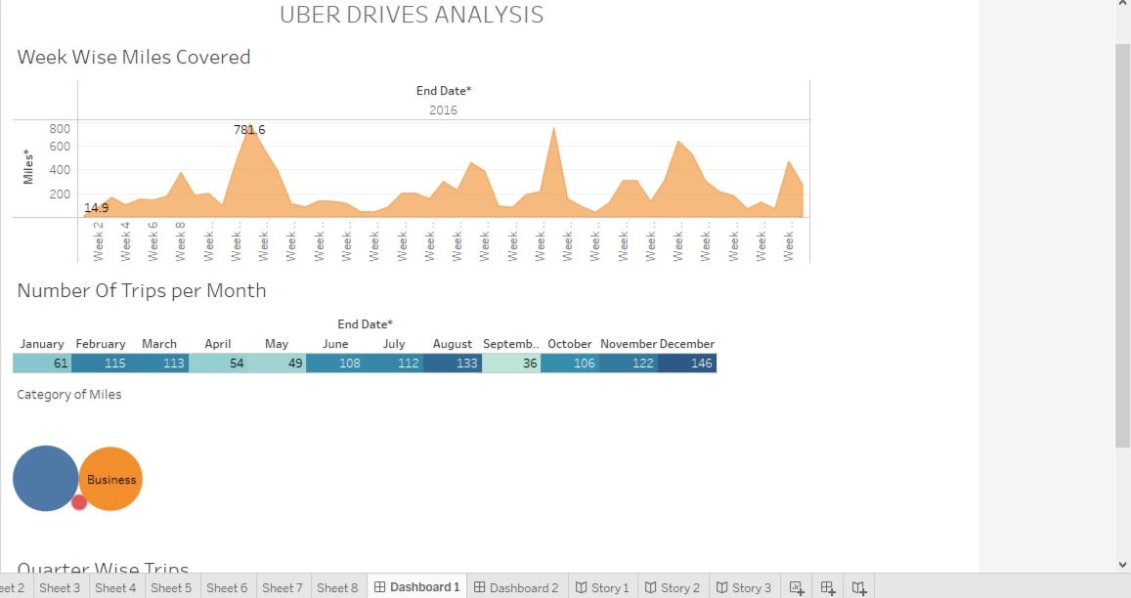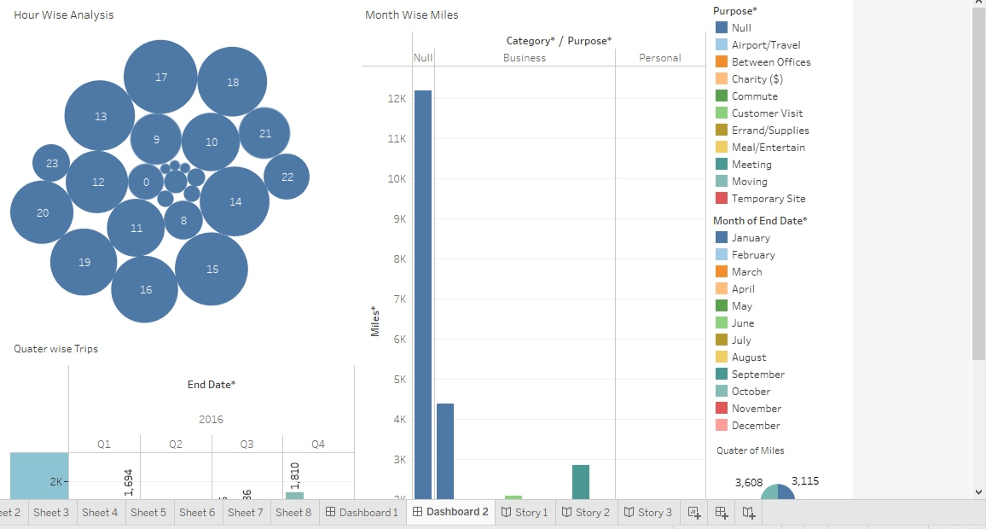

Story:





4. Advantages and Disadvantages

Advantages:

Convenience: Uber offers a convenient and hassle-free way to request and ride in a vehicle. With just a few taps on a mobile app, users can request a ride and track the driver's arrival in real-time. This eliminates the need to hail a taxi or wait at designated pickup points.

2. Availability: Uber operates in numerous cities worldwide, making it widely accessible to users. The large network of Uber drivers ensures that there is typically a vehicle available for pickup, even during peak hours or in remote areas. This availability contributes to reduced wait times for customers.

3. Cost-Effective: In many cases, Uber can be a cost-effective transportation option compared to traditional taxis. Depending on factors such as location, distance traveled, and time of day, Uber fares can often be lower than traditional metered fares or flat rates.

Disadvantages:

1. Surge Pricing: During periods of high demand, Uber implements surge pricing, which increases fares significantly. This surge pricing can catch riders off guard and lead to higher than expected costs for transportation.

2. Lack of Employee Benefits: Uber drivers are classified as independent contractors rather than employees. As a result, they may not receive employee benefits such as health insurance, paid time off, or retirement plans. This lack of benefits can impact the financial stability and well-being of drivers.

3. Safety Concerns: While Uber has implemented safety features and background checks for drivers, there have been occasional reports of safety incidents involving both riders and drivers. Despite precautionary measures, the nature of the platform and the possibility of interacting with unfamiliar individuals still pose some inherent risk.

Application:

The given data file for my project build. Given data files as zip format first extracted and added Tableau desktop and finally build my given project.

Conclusion:

In conclusion, the insights derived from Uber play a crucial role in shaping various aspects of transportation, business strategies, and urban planning. By illuminating patterns, preferences, and trends within the sharing economy, Uber's data-driven approach offers valuable information for decision-making and innovation.

The convenience and availability of Uber make it a preferred choice for many users, offering cost-effective transportation and pricing transparency. The safety features implemented by Uber provide a sense of security, although occasional safety concerns do exist. The cashless payment system and enhanced user experience through their mobile app contribute to a seamless and satisfactory ride-hailing service.

However, it is important to acknowledge some disadvantages. Surge pricing during periods of high demand can lead to unexpected fare increases, and the classification of drivers as independent contractors raises concerns about employee benefits. Safety incidents and regulatory challenges continue to pose challenges for Uber, and quality control remains an ongoing consideration.

7. Future scope:

1.Transportation Planning: Uber's extensive data on travel patterns, routes, and user preferences can provide valuable insights for city planners and transportation authorities.

2. Traffic Management: Uber's data can contribute to improving traffic management by providing real-time information on congestion, peak hours, and popular routes.

3. Urban Design and Development: Uber's data can influence urban development plans, helping city planners make informed decisions about the optimal locations for commercial centers.

4. Mobility Solutions for Underserved Areas: Uber's data can help identify transportation deserts or underserved areas where traditional transportation options are limited.

5. Demand-Responsive Public Transport: Insights from Uber can support the optimization and integration of demand-responsive transit services, allowing public transportation agencies to offer flexible, user-centered transport options.